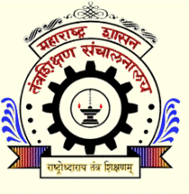 | Government College of Engineering  Station Road, Osmanpura, Aurangabad – 431 005  (An Autonomous Institute of Government of Maharashtra)  Phone : (0240) 2366180, 2326405 Fax : (0240) 2332835  E-Mail – principal@geca.ac.in, principalgeca@yahoo.com  Web – http://www.geca.ac.in

Dated: 18/06/2022

Office Order
The meeting of Departmental Research Committee in Mechanical Engineering Department, Government College of Engineering, Aurangabad, is scheduled on Tuesday 21 June 2022 CAD Lab in Mechanical Departmental at 3.00 pm. You are cordially invited for the meeting. All the Interested Students should remain present with the list of requisite Documents at 2.00 pm sharp. All the concerned Head of Department and Guide should remain present.

Time: 3 PM
Venue: CAD Lab of the Mechanical Engg. Department

Principal
Government College of Engineering,
Aurangabad

Copy to:
- Head, Mechanical Engineering Department
- PhD Coordinator for Mechanical Engineering Department
- Notice Board
- Website and social media Platforms

